Topics to Cover
- Frequency distribution and histogram with Excel Data Analysis Toolpak
- Other graphical methods
- JMP basics
- Histograms with JMP

1. Data Analysis Toolpak

For Mac
StatPlus:mac LE: http://www.analystsoft.com/en/products/statplusmacle/

How to Use
1. Install ToolPak (or Mac equivalent)
2. Enter data and range/bin limits in two different columns (fig. 1)
3. Data > Data Analysis (fig. 2)
4. In pop-up window, choose Histogram, press OK. (fig. 3)
5. In next pop-up window (fig. 4)
– Supply Input Range (data) Data Range; (ignore headers)
– Check 'Output Range' specify first cell of output range
– Check 'Cumulative Percentage'
– Press OK
6. Check results (fig. 5)

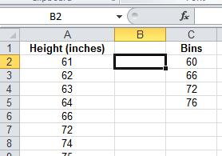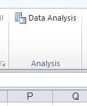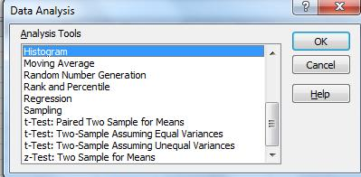
fig. 1 fig. 2 fig. 3

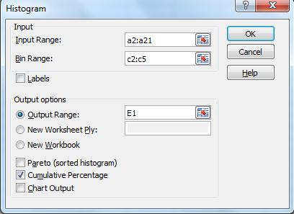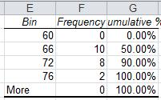
fig. 4 fig. 5

2. Other Graphical Methods

Stem-and-Leaf Plots

- See pp. 56-57 for example
- Rarely (if ever) used
- Unlikely to be on test

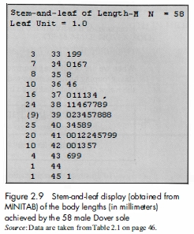

Frequency Polygons

- Not much different from histogram
- Just an x-y plot with x = range, y = frequency (or %, ...)
- Can be used to plot cumulative distributions
- See pp. 64-65 for examples

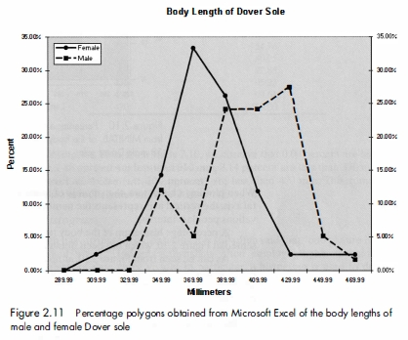

3. Frequency Distributions & Histograms with Excel

Classroom example: Construct & compare frequency and percentage distributions for Male and Female Dover sole length

3. JMP Basics

Components of JMP
- Data Table (.jmp files)
– like a spreadsheet, without formulas]
– can read an Excel table into JMP, or cut-and-paste data
- Scripts
– saves sequence of menu choices
– can be attached to Data Table
- Reports (.jrp files)
– don't need to save (yet)
– or cut-and-paste results into Word

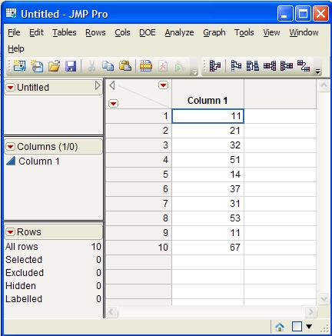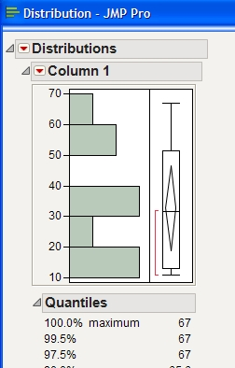
Data Table Report

Video: Get Started with Basic Statistics in JMP

4. Making a Histogram with JMP

Making a Histogram with JMP

- Start JMP
- File > New > (choose 'Data Table')
- Enter or cut-and-paste data into first column of Data Table
- Click above column to highlight
- Analyze > Distribution > (click Action: OK)
- Report should appear in new window

Saving a Report

- Position cursor within report, press <alt> key (or right-click on narrow ribbon above report)
- Click 'fat-plus' tool

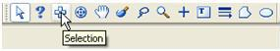

- Position 'fat-plus' tool in desired area of report, right-click, select Copy
- Paste selection into Word document

Homework

Analyze and compare frequency distributions for blood cholesterol in male/female patients:

Download data (Cholesterol homework data) from class webpage; note: male and female data on separate sheets/tabs.
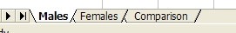

Use following ranges/bins:

Range | Bin
(mg/dL) | (mg/dL)
< 100 | 99
100 - <150 | 149
150 - < 200 | 199
200 - <250 | 249
250 - < 300 | 299
300 - < 350 | 349
350 - <400 | 399

1. For males and females separately, make a distribution table:

In separate columns show range, bin, frequency, percent, cumulative percent
- Label columns, include units of mg/dL.
- To get percents, divide frequencies by appropriate N (different for males and females).

2. For females only, make histogram:
- Resize histogram to look nice
- Place legend on bottom (not side)
- Label x-axis: Upper Limit of Range (Cholesterol, mg/dL)
- Add chart title: Distribution of Cholesterol for Females (mg/dL)
- If necessary fix secondary y-axis to range from 0 to 100%

3. Make final report comparing male and female distributions:

Col 1: Range
Col 2: Male frequency
Col 3: Male percentage
Col 4: Female frequency
Col 5: Female percentage

Remember to save your worksheet.

4. Based on the results, what conclusions can you reach concerning differences between male and female patients?

Place results of 1. (male and female), histogram (female), final comparison table, and answer to question into Word document.

Using JMP: Enter data for females into Data Table; produce histogram & basic statistics; cut-and-paste results into the same Word document as above.

